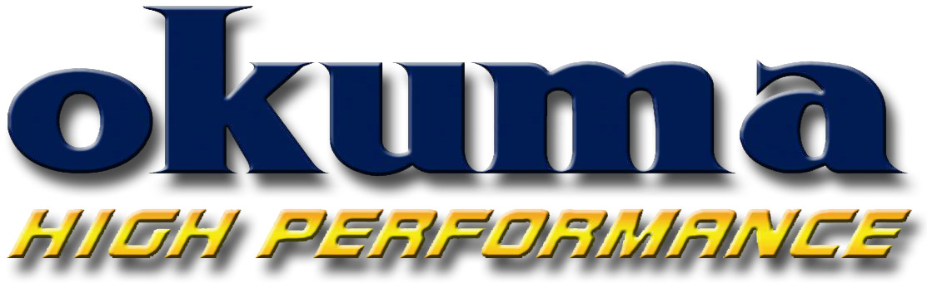
Okuma Fishing Tackle
2310 E. Locust Court
Ontario, CA 91761

Phone: (909) 923-2828
FAX: (909) 923-2909
www.okumafishing.com

For Immediate Release

DATE: 7/1/2010

Contact: Brandon Cotton
(909) 923-2828 Ext. 111
E-mail: brandon.cotton@okumafishing.com

Andros Jigging Rods

ONTARIO, Calif. – Okuma’s new Andros jigging rods have been designed to handle the most powerful saltwater gamefish.
Built with actions to compliment vertical jigging, Andros rods are made from a powerful IM6 graphite blank construction. The two-piece rods utilize a handle ferrule connection, which allows for a more natural bend of the rod and a one-piece feel. The two-piece design also allows for easy transportation.
In addition to the strength and power of the rod, the Andros also features a split-butt design for reduced weight and added comfort while jigging. The ALPS 316 stainless steel guide frames with Zirconium inserts stand up to mono and braided lines and the power of big fish.
Other features include an ALPS machined aluminum reel seat with finger grooves for comfort, orange carbon fiber pipe under the reel seat, and an orange anodized aluminum, etched butt cap.
Andros jigging rods are designed to compliment Okuma’s new award-winning Andros 5II lever drag reels, and are backed by a 1-year warranty.

